* **BATCH ID: WiproNGA_DWS_B5_25VID2550**
* **NAME:** Shrawani Shyam Balwadkar
* **RPS USER ID:** 34932
* **DATE**: 29-08-2025
* **Email**: shrawanibalwadkar684@gmail.com

**TOPIC:**

1.Creating a Dashboard.

WHAT IS NEXTHINK

Nexthink is a digital experience (DEX) management platform that helps organizations gain insights into the digital workplace, enabling IT teams to monitor, diagnose, and resolve issues before users even report them. It offers real-time analytics, automation, and employee feedback tools to enhance the digital workplace experience.

**Core Platform Features:**

* **Real-time Monitoring and Analytics:** Nexthink collects and analyzes data from employee devices, providing visibility into application performance, network connectivity, and user interactions.
* **Automated Remediation:** The platform can automatically fix issues and deploy solutions based on predefined policies, reducing the need for manual intervention.
* **Employee Engagement:** Nexthink allows IT teams to engage with employees through surveys, notifications, and feedback mechanisms, ensuring that they are aware of any potential issues and can contribute to their resolution.
* **Integration with Other Tools:** Nexthink can integrate with various third-party IT tools, enabling IT teams to leverage existing systems and streamline their processes.
* **AI-Powered Insights:** The Nexthink Infinity platform utilizes AI to perform root-cause analysis, provide global cloud insights, and offer step-by-step guidance for resolving or preventing issues.
* **Digital Workplace Observability:** Nexthink provides comprehensive visibility into the digital workplace, enabling IT teams to proactively prevent issues and resolve critical disruptions, ultimately driving workforce efficiency.

***Creating a Dashboard:***

To create basic dashboards and alerts in Nexthink, you'll start by creating a module (or reusing an existing one) and adding a dashboard to it. For alerts, you'll configure service-based or investigation-based alerts. You can then view alerts in the Portal or Finder.

1. **Choose a Module Type:** Decide on the type of module you need (e.g., Basic for metrics, Service Monitoring for service health).
2. **Create or Reuse:** Create a module or reuse an existing one.
3. **Add Dashboard:** Add a new dashboard to the chosen module.
4. **Edit and Customize:** Edit the content of the dashboard, including adding widgets, graphs, and descriptions.

**Creating Alerts:**

1. **Service-Based Alerts:**

* Log in to the Portal as an administrator.
* Go to the Alerts dashboard under Content Management.
* Click the plus sign to create a new alert.
* Configure the alert's name, description, category, and service.
* Specify the threshold for triggering the alert (yellow or red).

2. **Investigation-Based Alerts:**

* These alerts are triggered by specific investigations.
* You can configure them within the Nexthink web interface.

3. **Receiving Alerts:**

* You can receive alerts via email or the system log of the Appliance.
* Configure SMTP settings for email notifications.

**Viewing Alerts:**

* **Portal:** You can see service-based alerts in the Portal.
* **Finder:** You can see investigation-based alerts on devices in the Device view of Finder.
* **Finder Settings:** View role-based alerts in the Settings section of Finder.

**Creating a new dashboard**

**Installing a built-in dashboard from Library**

To install a dashboard from Nexthink Library:

* Select **Nexthink Library** from the main menu.
* Search for the dashboard content you wish to install.
* **Install** the content. Refer to the [Nexthink Library](https://docs.nexthink.com/platform/user-guide/nexthink-library) documentation for more information.
* Navigate back to the Live Dashboards administration page where you can edit and customize the library dashboard
* Publish the library dashboard when you are ready to use it.

You can update the previously installed library dashboards if a newer version is available.

**Creating a custom dashboard**

To create a custom dashboard:

1. Open **Live Dashboards** → **Manage live dashboards** from the navigation menu.
2. Click on **Create a dashboard** in the top-right corner of the empty **Dashboards** page.
3. Enter a meaningful name for the dashboard and click **Save**.

**Editing dashboard content**

To edit a dashboard, click on a dashboard’s name from the Live Dashboards main menu or navigate to the **Dashboards** page by clicking the **Manage live dashboards** button.

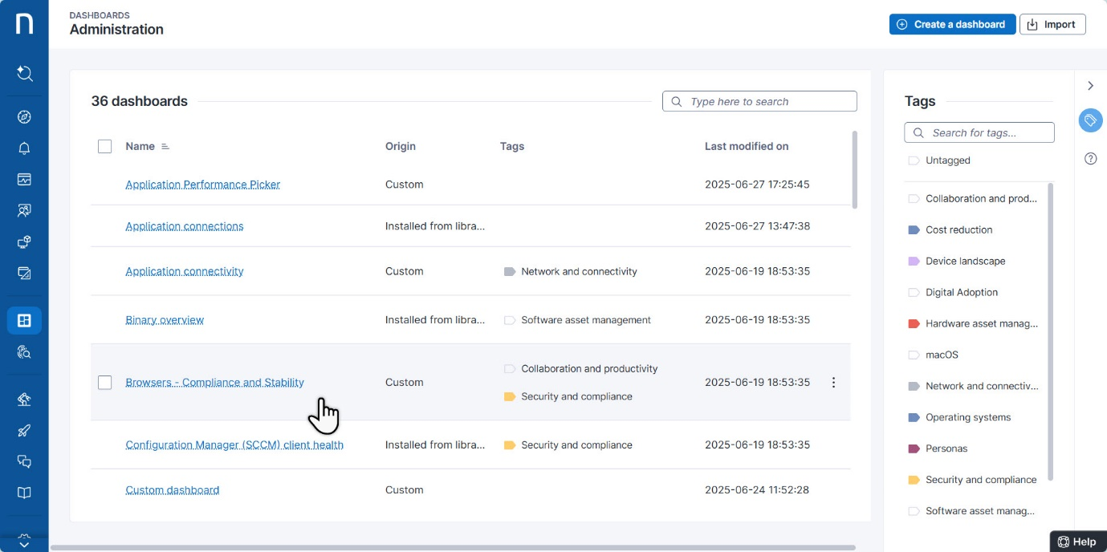

Use the action menu in the top-right corner of the page to activate the dashboard’s **edit mode**.

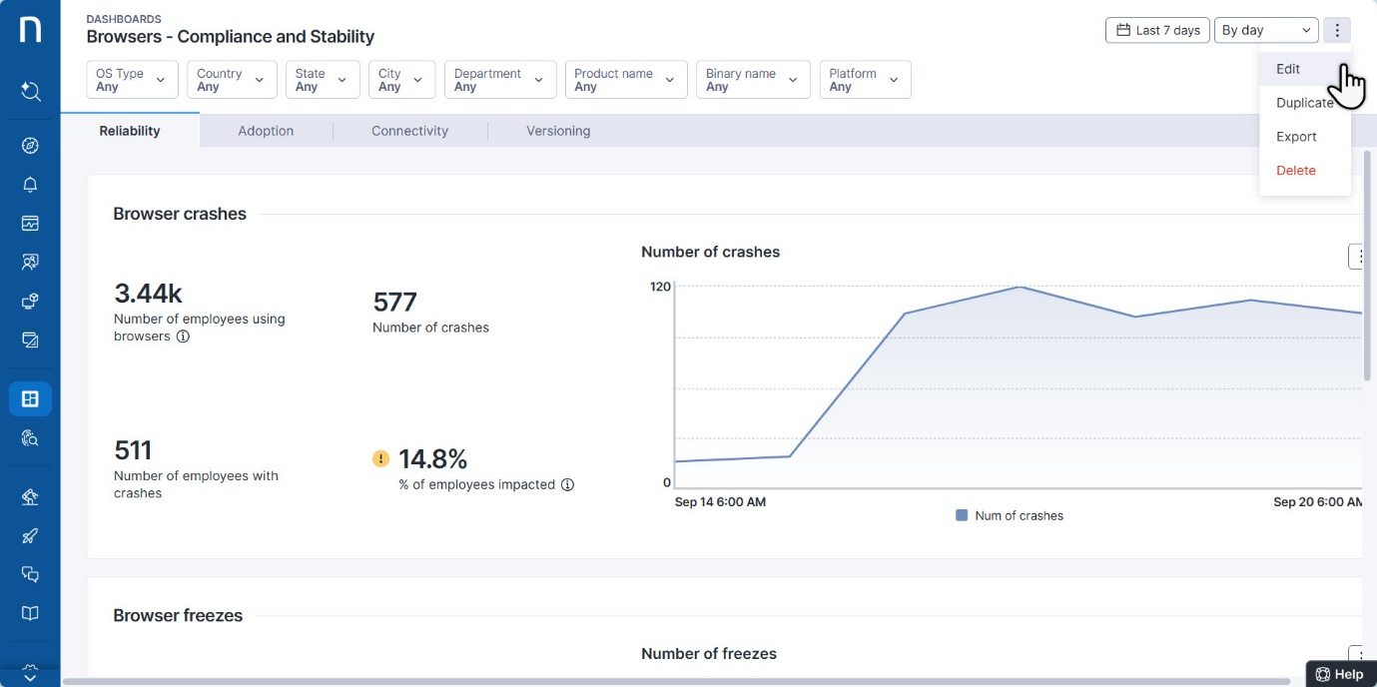

When you activate **edit mode,** the Nexthink web interface displays editable dashboard elements in light blue.

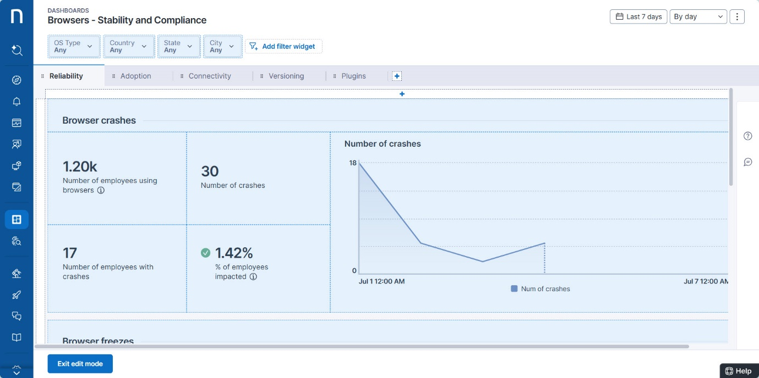

While in edit mode, you can modify the dashboard content:

* [Add](https://docs.nexthink.com/platform/user-guide/live-dashboards/managing-live-dashboards#adding-widgets) and [manage widgets](https://docs.nexthink.com/platform/user-guide/live-dashboards/managing-live-dashboards#managing-widgets).
  + Optionally, [Copy/paste](https://docs.nexthink.com/platform/user-guide/live-dashboards/managing-live-dashboards#copying-and-pasting-widgets-directly-in-view-mode) widgets.
* [Add](https://docs.nexthink.com/platform/user-guide/live-dashboards/managing-live-dashboards#adding-widget-filters) and [manage widget filters](https://docs.nexthink.com/platform/user-guide/live-dashboards/managing-live-dashboards#managing-widget-filters).
* [Add](https://docs.nexthink.com/platform/user-guide/live-dashboards/managing-live-dashboards#adding-tabs) and [manage tabs](https://docs.nexthink.com/platform/user-guide/live-dashboards/managing-live-dashboards#managing-tabs) and [tab descriptions](https://docs.nexthink.com/platform/user-guide/live-dashboards/managing-live-dashboards#adding-tab-descriptions).
* [Rename](https://docs.nexthink.com/platform/user-guide/live-dashboards/managing-live-dashboards#renaming-a-dashboard-and-changing-its-properties) a dashboard and change its properties.

Your ability to access or edit **shared** dashboards created by others depends on:

* Your user [role](https://docs.nexthink.com/platform/user-guide/administration/account-management/roles#roles-livedashboards) permissions for Live Dashboards.
* Your **View** or **Edit** rights for the specific shared dashboard.

Refer to the [Sharing dashboards by granting View/Edit rights](https://docs.nexthink.com/platform/user-guide/live-dashboards/managing-live-dashboards#managinglivedashboards-sharingdashboardssharing) section on this page that maps user access and actions based on the aforementioned combination of permissions.

**Adding widgets**

To add widgets in edit mode:

1. Click on the **+** icon to add a new widget.
2. Select the widget type you want to add:
   * **Visualizations** to present data as a line chart, bar chart, gauge chart, table or other type of visualization.
   * **Heading** to enter the name of the new section or a group of widgets on your dashboard.
3. Optionally, **Paste** a widget that you've previously copied to the clipboard, for example from another tab or dashboard, to quickly reuse its configuration.
4. [Fill in the visualization fields](https://docs.nexthink.com/platform/user-guide/live-dashboards/managing-live-dashboards#filling-in-widget-visualization-fields) in the **Add a widget** pop-up and **Save widget**.

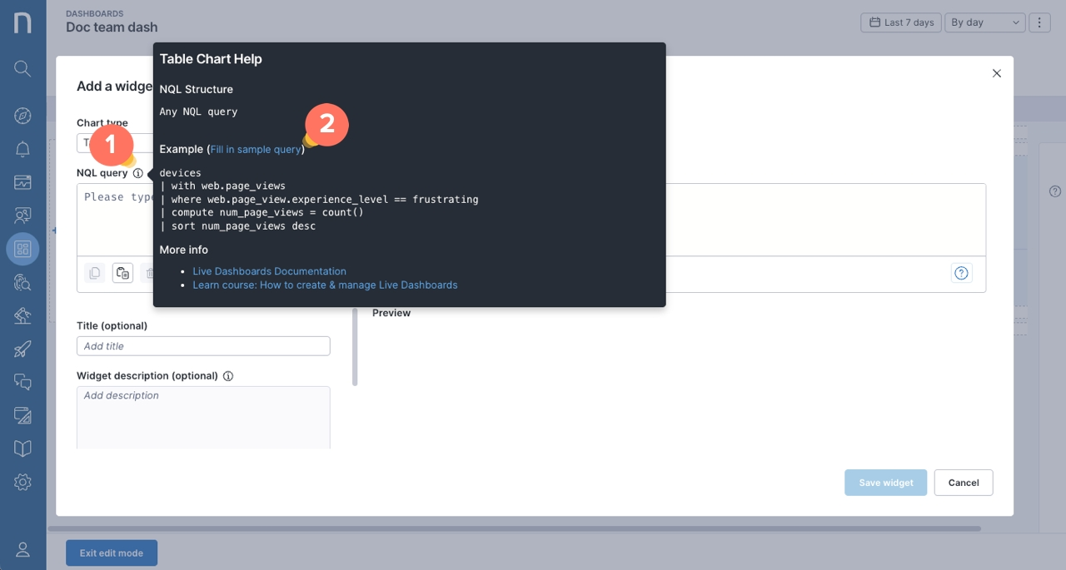

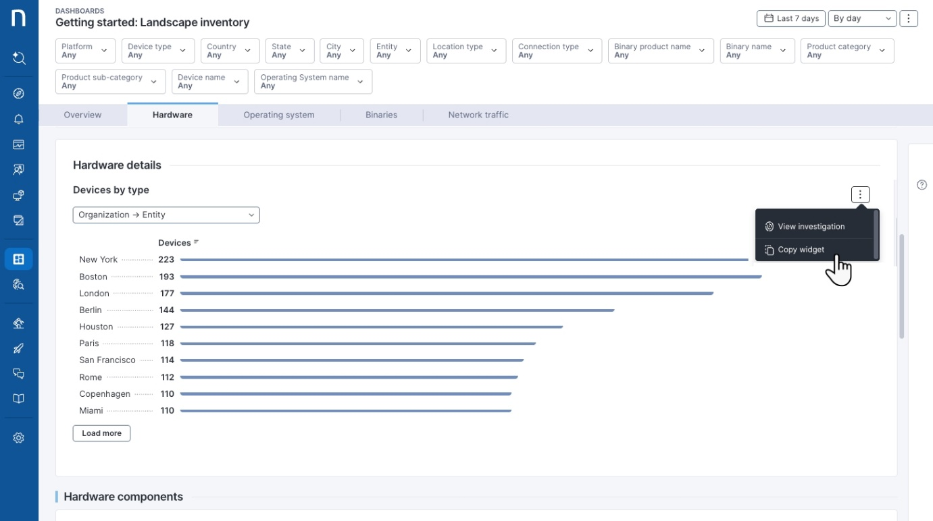

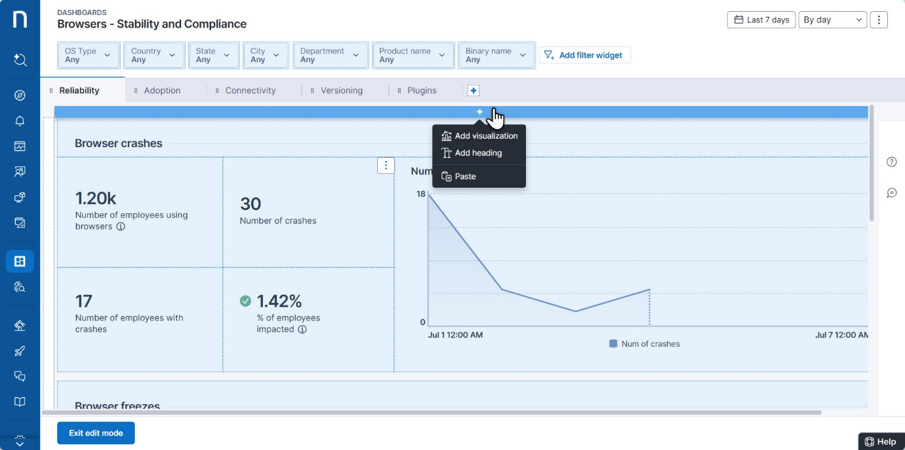

**Managing widgets**

To manage widgets in edit mode, hover over an existing widget to open the action menu.

1. Select the **Edit** option to modify the [visualization fields](https://docs.nexthink.com/platform/user-guide/live-dashboards/managing-live-dashboards#filling-in-widget-visualization-fields) of the widget.
2. Select **Copy widget** to copy it to the browser clipboard and then paste it in any dashboard that you have edit permissions to. Use the add widget (the **+** icon) to paste it to your desired location. Note that the first time you try to paste, the browser will ask you to grant permissions to access the browser clipboard.
3. Select **Delete** to remove the widget.
4. Select **Group with right/left/top/bottom** option to cluster adjacent widgets under the same section or heading.

Click **Exit edit mode** to save changes.

To move a widget, click and drag the widget box highlighted in light blue.

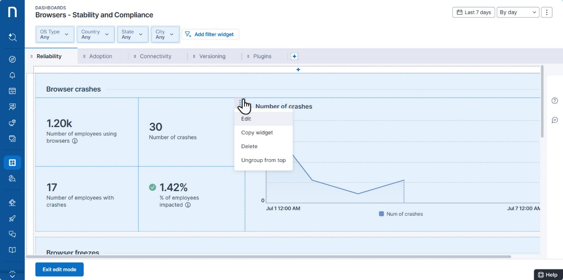

**Adding widget filters**

Widget filters allow you to view a subset of the data, displaying values from a specific field. The system currently supports strings, enumerators, Booleans and versions as field types.

To add a widget filter in edit mode:

1. Click **Add filter widget** in the top-right corner of the page.
2. Fill in the Add filter widget popup to define the custom filter widget:
   * **Filter label**: provide a meaningful label for the filter widget.
   * **Table** and **Field**: select the NQL table and field to populate the filter’s drop-down menu.
   * **User can select multiple values:** tick this option to enable users to select one or multiple values from the filter's drop-down menu.
3. **Save filter** and **Exit edit mode** to use widget filters.

Filter widgets operate on a dashboard level and apply to charts in all dashboard tabs.

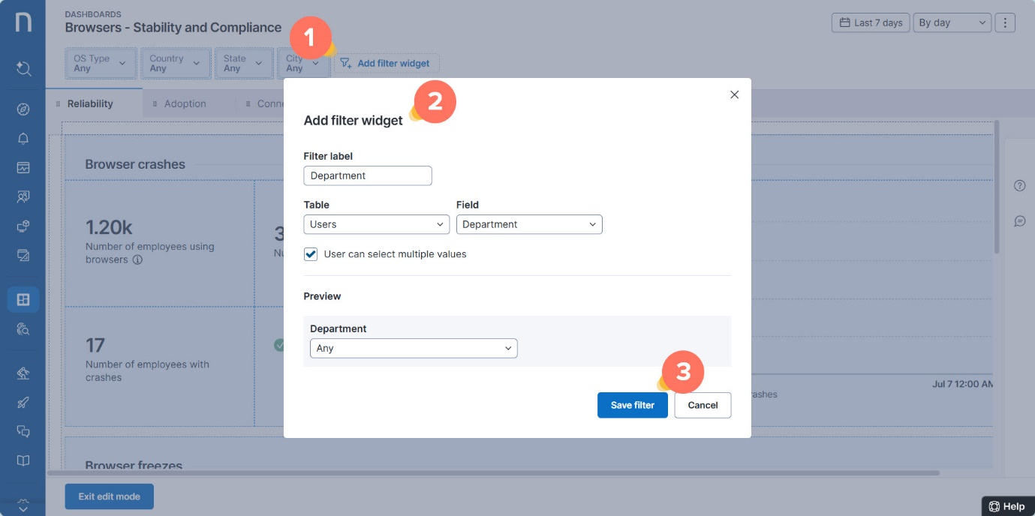

**Managing widget filters**

To manage widget filters in edit mode:

1. Hover over the top-right corner of the filter widget to open the action menu.
2. Select the **Edit** or **Delete** option.
3. Click **Exit edit mode** to save changes.

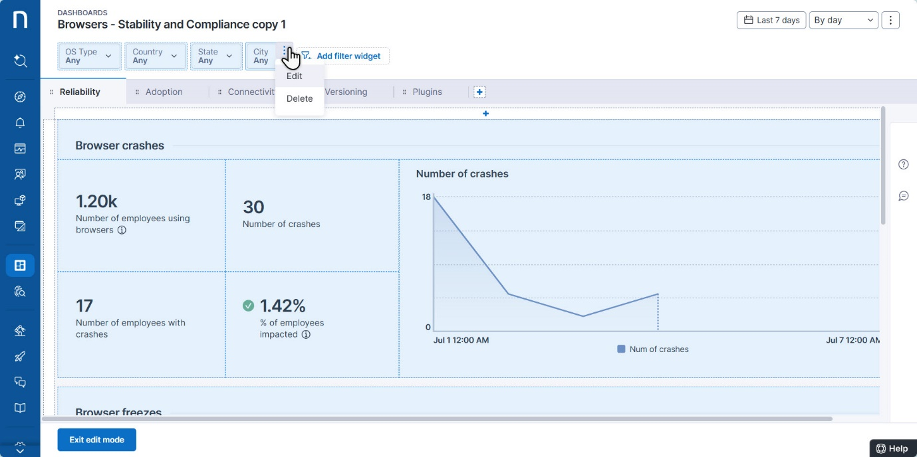

To change the position of a widget filter in the Nexthink web interface, delete the filter and then add it back into the desired position.

**Adding tabs**

Further organize widgets by adding tabs to the dashboard. Each tab can contain different sets of widgets and layouts.

To add tabs in edit mode:

1. Click on the **+** icon below the filter bar to add a tab.
2. Use the tab’s action menu to rename or delete a tab.
3. Click and drag on individual tabs to reorder them.
4. Click **Exit edit mode** to save changes.

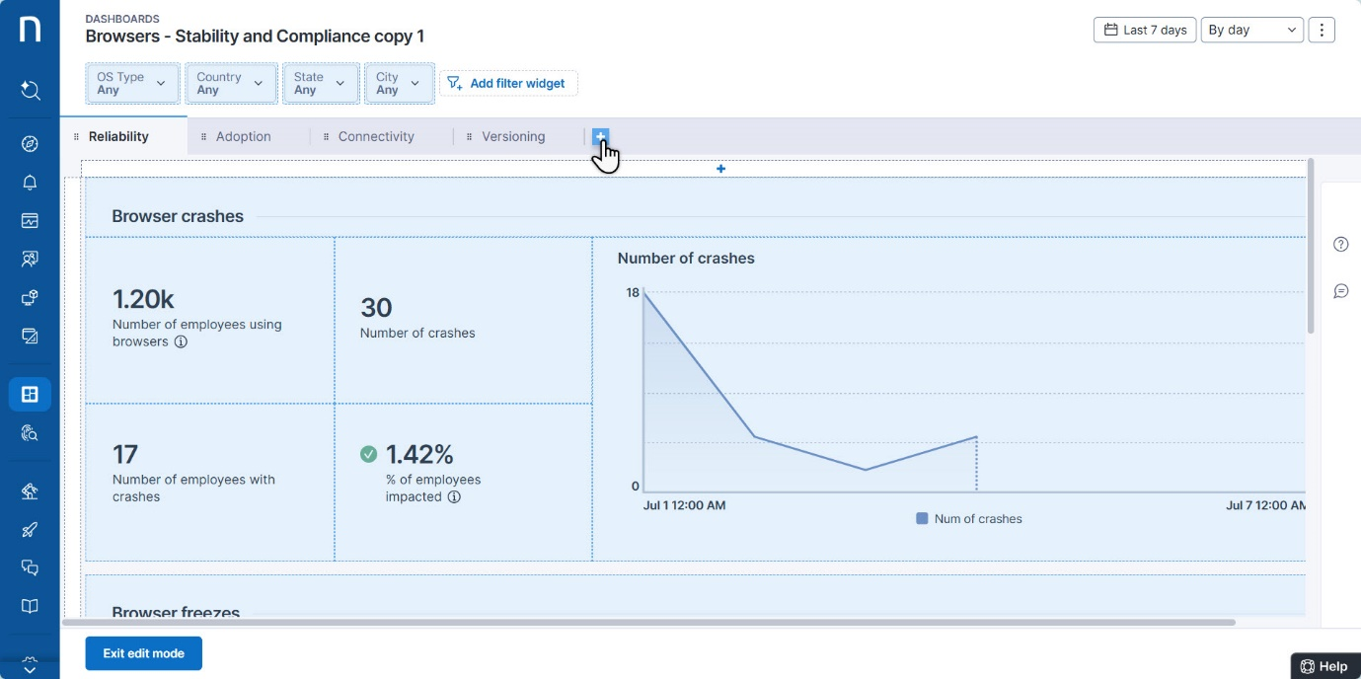

When adding tabs to a dashboard, consider the following:

* The first tab you create takes on the layout of all existing widgets in your dashboard.
* Add up to 8 tabs in total.
* The system exclusively runs the NQL query of the currently selected tab.
* The [timeframe picker](https://docs.nexthink.com/platform/user-guide/live-dashboards/widget-types/timeframe-picker) and filters operate on a dashboard level and apply to charts in all tabs.

**Managing tabs**

To manage tabs in edit mode:

1. Hover over the tab and click on the action menu.
2. Choose the **Rename** or **Delete** option.
3. Click **Exit edit mode** to save changes.

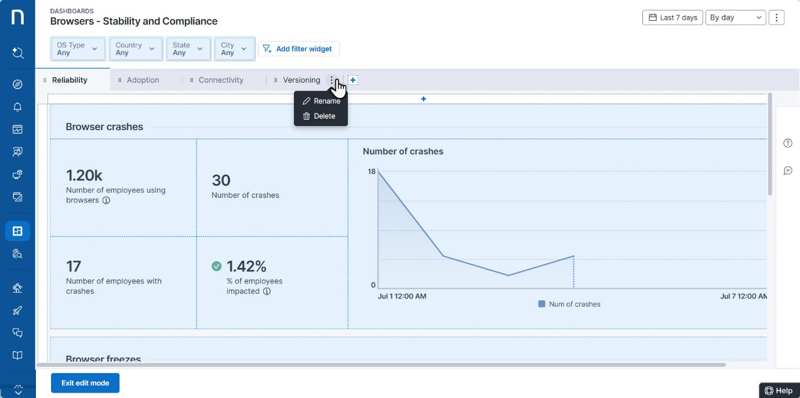

When managing tabs, consider the following:

* Deleting the last remaining tab removes the tab, but keeps all widgets/visualizations.
* If there are multiple tabs, deleting a tab deletes all widgets on that tab and removes the tab.

**Adding tab descriptions**

Tab descriptions allow you to communicate the purpose of the dashboard to other users by providing details of how to interpret and use the data in a specific tab.

To add tab descriptions in edit mode:

1. Click on the **question mark** on the right side of the Nexthink web interface.
2. After the bar expands, click **Edit** to add text.
3. **Save** the tab description.
4. Click **Exit edit mode** to save changes.

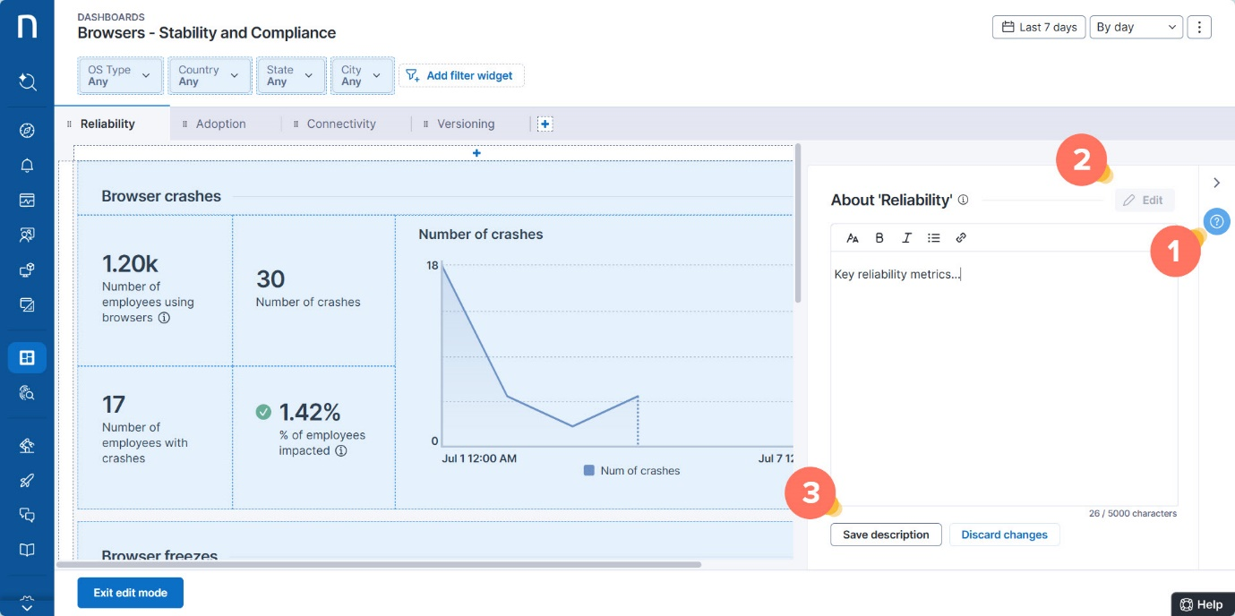

When adding tab descriptions, consider the following:

* There is a rich text editor with the following features: font size, bold, italics, bullets, links.
* Descriptions are tab-specific.

**Managing dashboards**

To manage an existing dashboard, click on a dashboard’s name from the Live Dashboards main menu or navigate to the **Dashboards** page by clicking the **Manage live dashboards** button.

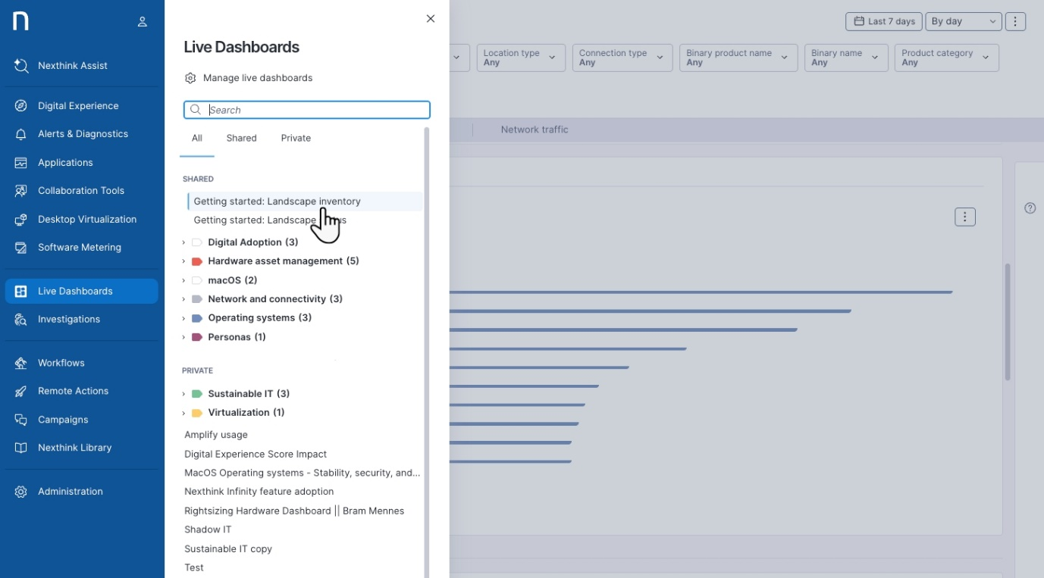

Use the action menu in the top-right corner of the dashboard page to:

* [Edit](https://docs.nexthink.com/platform/user-guide/live-dashboards/managing-live-dashboards#managinglivedashboards-editingdashboardcontenteditmode) dashboard content (edit mode).
* [Duplicate](https://docs.nexthink.com/platform/user-guide/live-dashboards/managing-live-dashboards#managinglivedashboards-duplicatingadashboard) dashboards.
* [Export](https://docs.nexthink.com/platform/user-guide/live-dashboards/managing-live-dashboards#managinglivedashboards-exportinganexistingdashboardexport) a dashboard as a file.
* Delete a dashboard.



**Renaming a dashboard and changing its properties**

To rename a dashboard or one of its properties in edit mode:

1. Hover and click on the action menu in the top-right corner of the page.
2. Choose the **Edit properties** option.

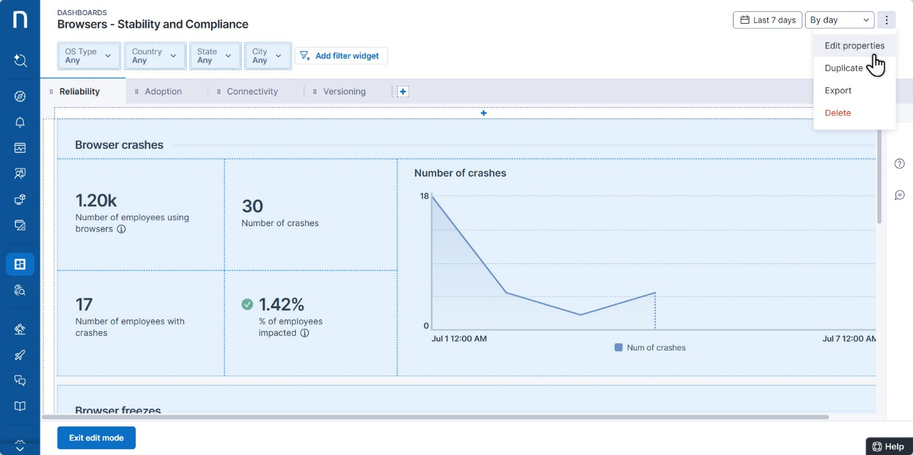

1. Fill in the fields in the **Dashboard properties** pop-up:
   * **Name**: This field allows you to rename the dashboard.
   * **Default timeframe and graularity**: This drop-down allows you to set the default timeframe and granularity to apply when a user opens and loads the dashboard. The global default timeframe is **Last 7 days**.

Refer to the [Using Live Dashboards](https://docs.nexthink.com/platform/user-guide/live-dashboards/using-live-dashboards) documentation to learn how to use the timeframe picker.

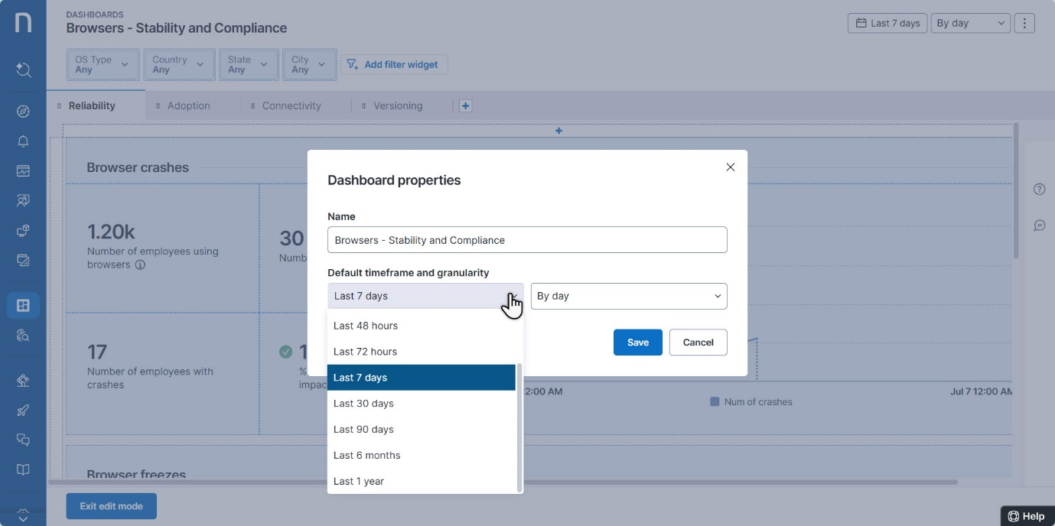

**Duplicating a dashboard**

By default, dashboards created from duplication are [private](https://docs.nexthink.com/platform/user-guide/live-dashboards/managing-live-dashboards#created-private-dashboards-versus-shared-dashboards) and visible only to the creator—unless they are shared with others.

To duplicate a dashboard, click on a dashboard name from the Live Dashboards main menu or select a dashboard from **the Live Dashboards Manage live dashboards** button.

From the specific dashboard page:

1. Click on the action menu in the top-right corner of the page.
2. Choose the **Duplicate** option from the action menu.

Duplicating a dashboard opens a new duplicate copy with an automatically generated name.

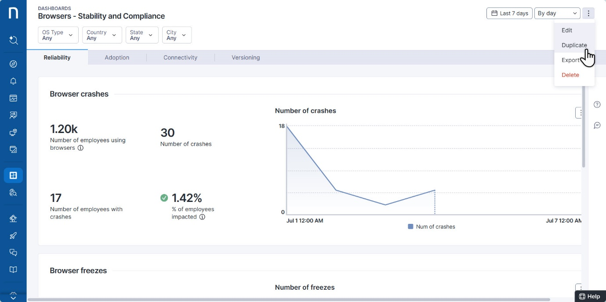

**Exporting and importing an existing dashboard**

The import and export functionality is restricted to those with the **Manage all dashboards** [permissions](https://docs.nexthink.com/platform/user-guide/live-dashboards/managing-live-dashboards#managinglivedashboards-sharingdashboardssharing).

By default, dashboards created from imports are [private](https://docs.nexthink.com/platform/user-guide/live-dashboards/managing-live-dashboards#created-private-dashboards-versus-shared-dashboards) and visible only to the creator—unless they are shared with others.

**Exporting an existing dashboard**

The import and export functionality is restricted to those with the **Manage all dashboards** [permissions](https://docs.nexthink.com/platform/user-guide/live-dashboards/managing-live-dashboards#managinglivedashboards-sharingdashboardssharing).

To export a dashboard, click on a dashboard’s name from the Live Dashboards main menu or navigate to the **Dashboards** page by clicking the **Manage live dashboards** button.

From the dashboard page:

1. Click on the action menu in the top-right corner of the page.
2. Choose the **Export** option from the action menu. The system exports dashboards as JSON files

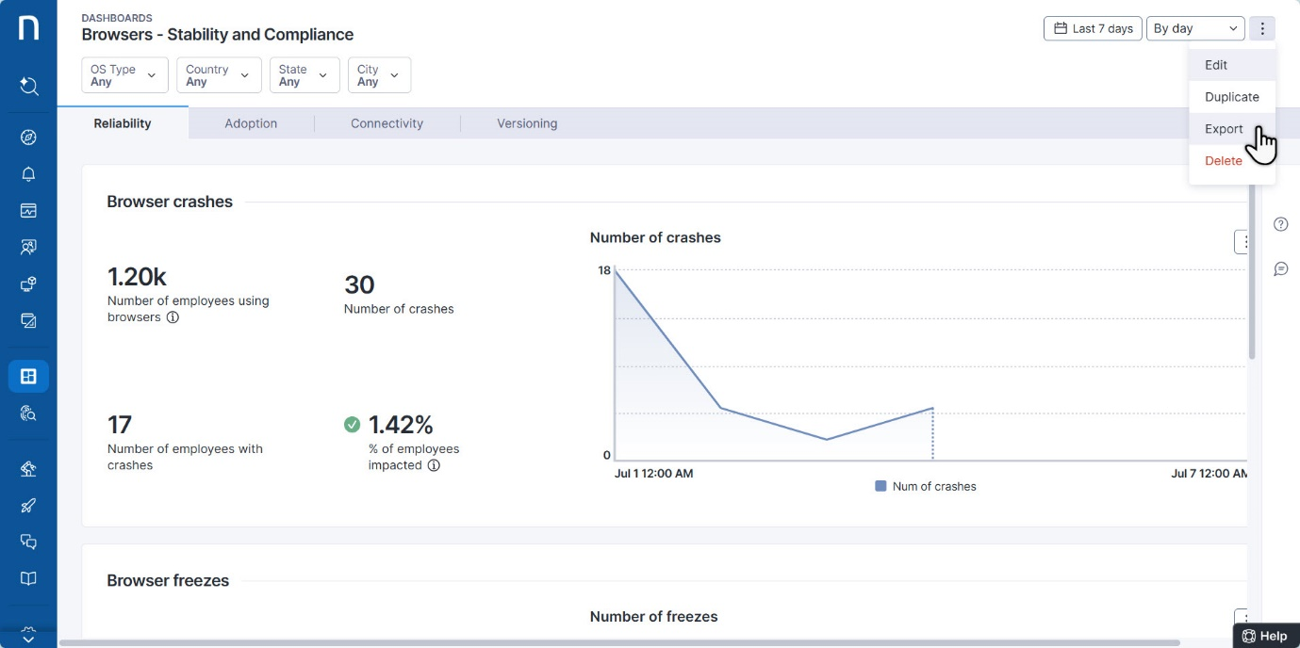

**Importing a dashboard**

Import custom dashboards previously [exported](https://docs.nexthink.com/platform/user-guide/live-dashboards/managing-live-dashboards#managinglivedashboards-exportinganexistingdashboardexport) from the **Live Dashboards** module, or pre-built dashboards from [Nexthink Library](https://docs.nexthink.com/platform/user-guide/nexthink-library).

To import live dashboards—in JSON—from your local device:

1. Click the **Import** button in the top-right corner of the **Live dashboards** → **Manage live dashboards** page.
2. **Choose** or **drag** multiple JSON files from your hard drive to import them into the system.
   * All imported items from local devices are listed as [custom](https://docs.nexthink.com/platform/user-guide/live-dashboards/managing-live-dashboards#custom-dashboards) content.

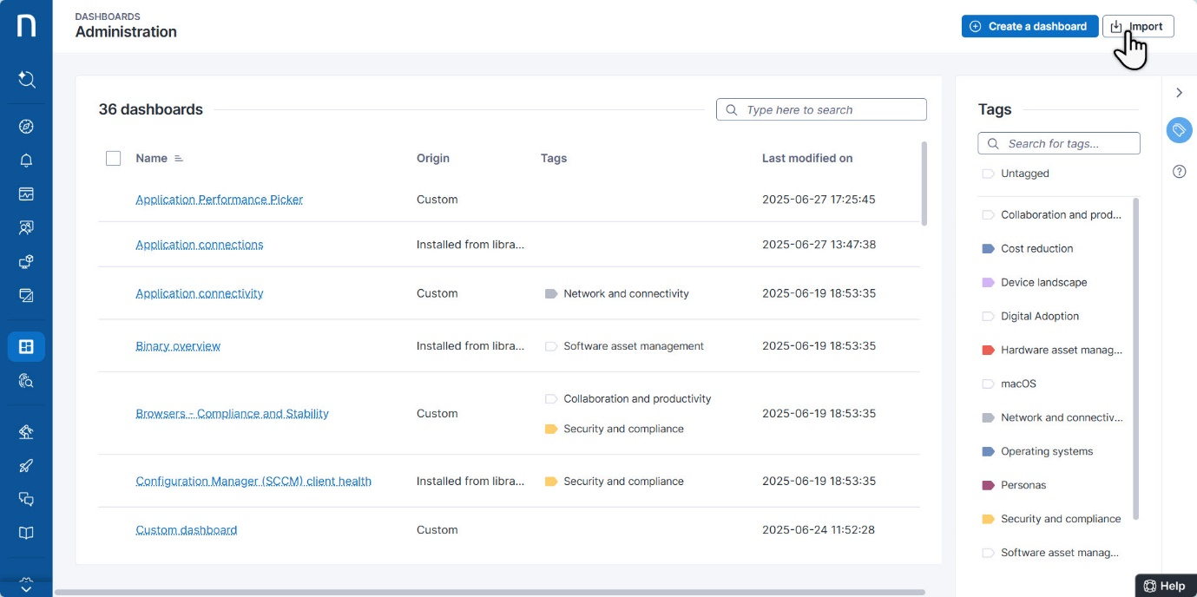

**Tagging dashboards**

Tagging allows you to quickly sort dashboards. Open the **Tags** right-side panel to:

* Search for a specific tag at the top of the panel.
* Select one or more tags to filter the dashboard table.

To add one or more tags to a dashboard, from the **Live dashboards** → **Manage live dashboards** page.:

1. Hover over a dashboard to display the action menu and choose **Manage tags**.
2. From the **Manage tags** pop-up you can:
   * Type in a new tag or choose an existing one to add it to the dashboard.
   * Open the action menu of a specific tag item to **Delete tag** or change the tag color.
     + Deleting a tag only removes it from the dashboard it is associated with.
3. Alternatively, select multiple dashboards to **Manage tags** in bulks.

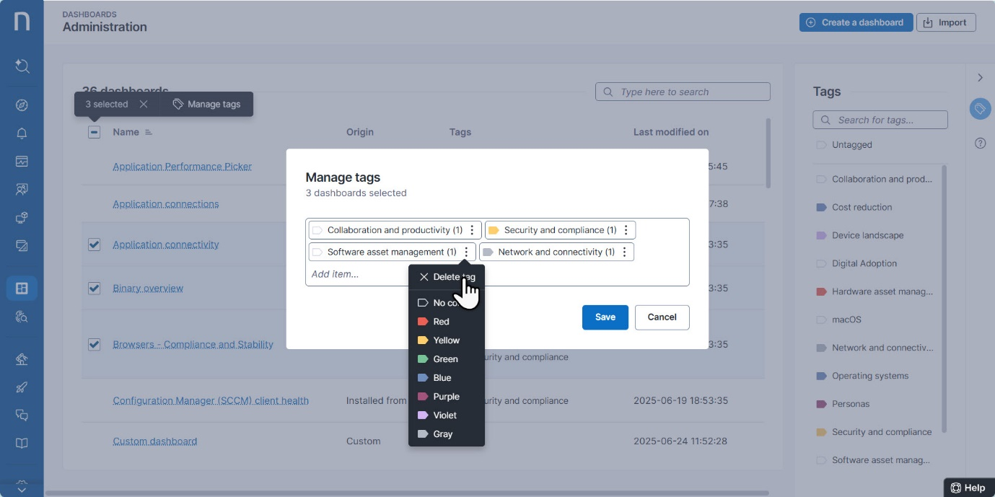

**Sharing dashboards by granting View/Edit rights**

The **Live Dashboards** navigation menu differentiates between **private** and **shared** dashboards, sorting each tab by [tags](https://docs.nexthink.com/platform/user-guide/live-dashboards/managing-live-dashboards#managinglivedashboards-taggingdashboardstaggingld).

* The **Private** tab displays dashboards you create and have not shared.
* The **Shared** tab lists dashboards that areshared with others, including those created by other users and built-in system dashboards.

Newly created, [duplicated](https://docs.nexthink.com/platform/user-guide/live-dashboards/managing-live-dashboards#managinglivedashboards-duplicatingadashboard) or [imported](https://docs.nexthink.com/platform/user-guide/live-dashboards/managing-live-dashboards#managinglivedashboards-importingdashboards) dashboards are private by default and visible only to the creator—unless shared with others.

As a user, your ability to access or edit **shared** dashboards created by others depends on two things:

* Your user [role](https://docs.nexthink.com/platform/user-guide/administration/account-management/roles#roles-livedashboards) permissions for Live Dashboards.
* Your **View** or **Edit** rights on the specific **shared** or built-in dashboard.

The following sections on this page map user access and actions based on the aforementioned combination of permissions:

* [Access scenarios for shared dashboard permissions](https://docs.nexthink.com/platform/user-guide/live-dashboards/managing-live-dashboards#managinglivedashboards-scenariosforshareddashboardpermissions)
* [Available actions by user role and shared dashboard permissions: Built-in dashboards](https://docs.nexthink.com/platform/user-guide/live-dashboards/managing-live-dashboards#managinglivedashboards-sharedashboardpermissionsreferencetable)
* [Available actions by user role and shared dashboard permissions: Custom dashboards](https://docs.nexthink.com/platform/user-guide/live-dashboards/managing-live-dashboards#available-actions-by-user-role-and-shared-dashboard-permissions-custom-dashboards)



If you have **Manage shared dashboards** [permissions](https://docs.nexthink.com/platform/user-guide/administration/account-management/roles#roles-livedashboards), you can share specific dashboards with users who don’t have Live Dashboards access.

1. Navigate to **Live Dashboards** > **Manage live dashboards**.
2. Hover over a dashboard to reveal the action menu on the right side of the table.
3. Choose the **Share** option.

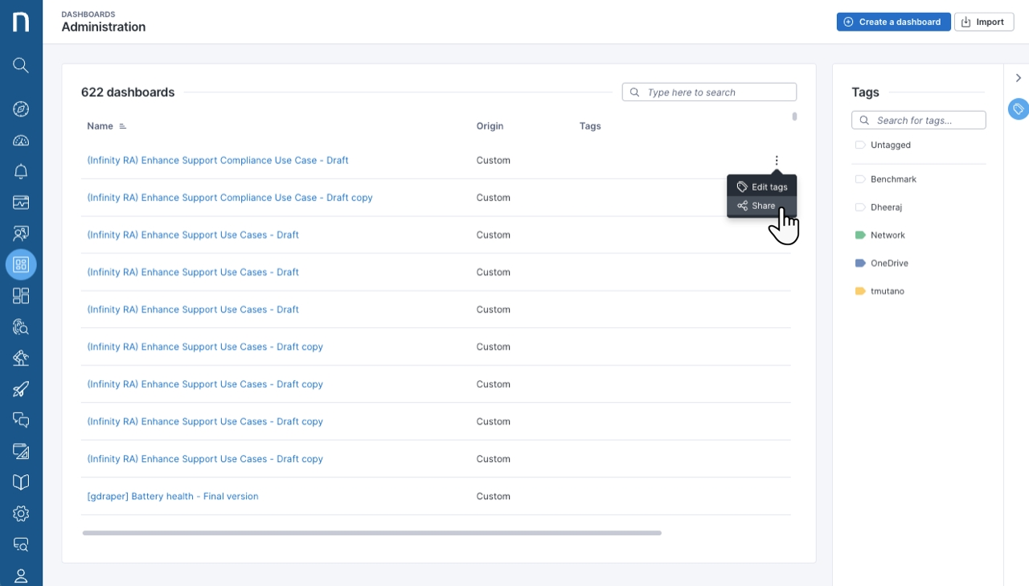

1. Fill in the **Share dashboard** pop-up:
   * Add the profile you wish to share the dashboard with.
   * Select permissions for the profile from the drop-down menu. The options are **View** or **Edit**.
   * Click **Grant permissions** to add them to the dashboard list.

Giving **Edit** permissions does not grant **View** permissions. Both permissions are required for editing rights.

